Deliverable: Create and deploy a cloud formation stack that creates an EC2 instance and installs Apache web server utilizing the user Data in the cloud formation template/ script.

Step 1: Select Cloud Formation

Image:



Step 2: Create Stack

Image:

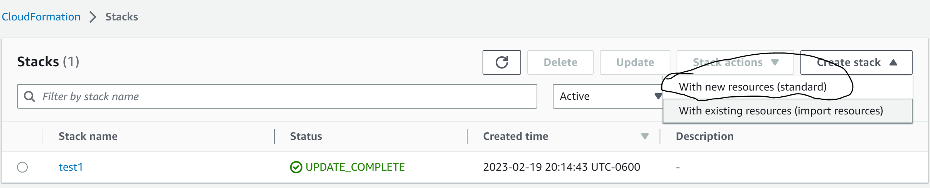

-

Step 3: Create a Designer Template and select create template in designer

Image:

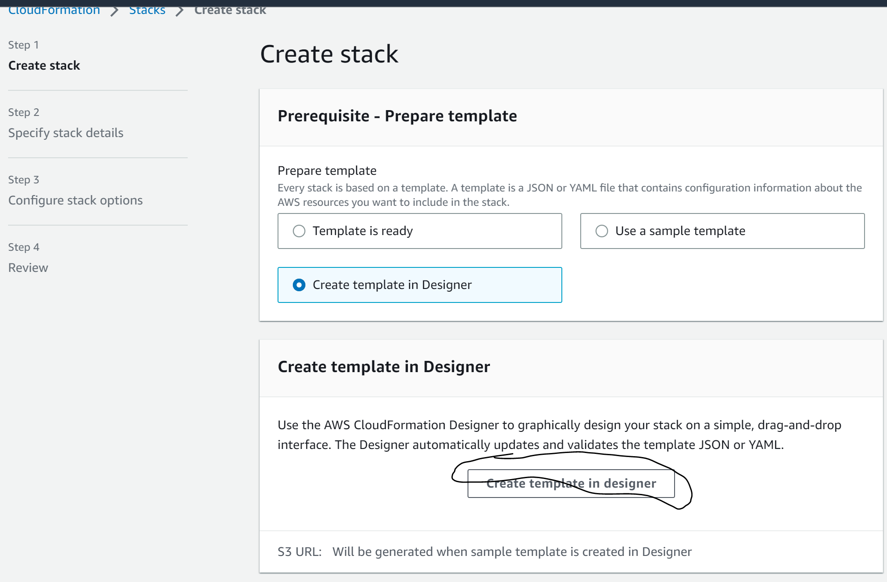

-

Step 4: Navigate to EC2

Image:

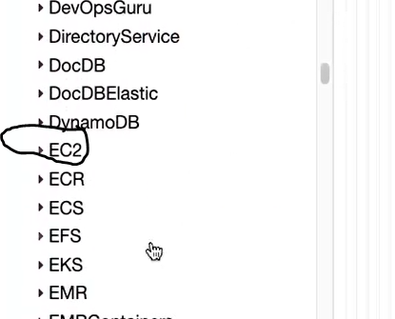

-

Step 5: Drag and drop EC2 instance into diagram

Image:

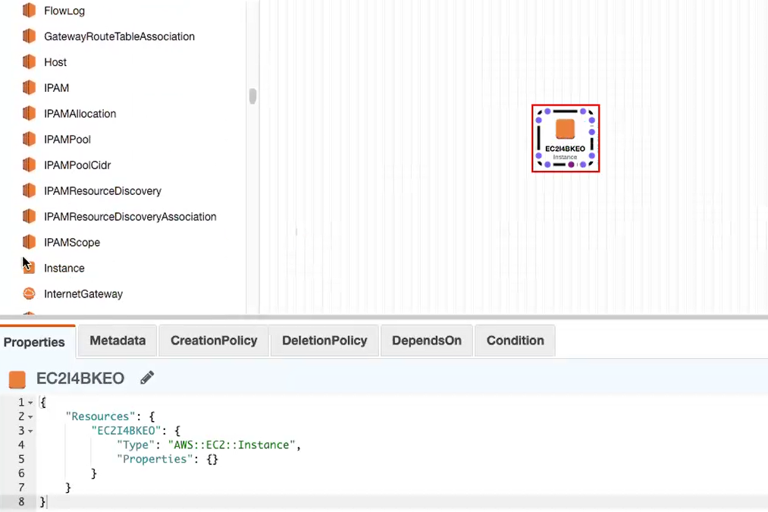

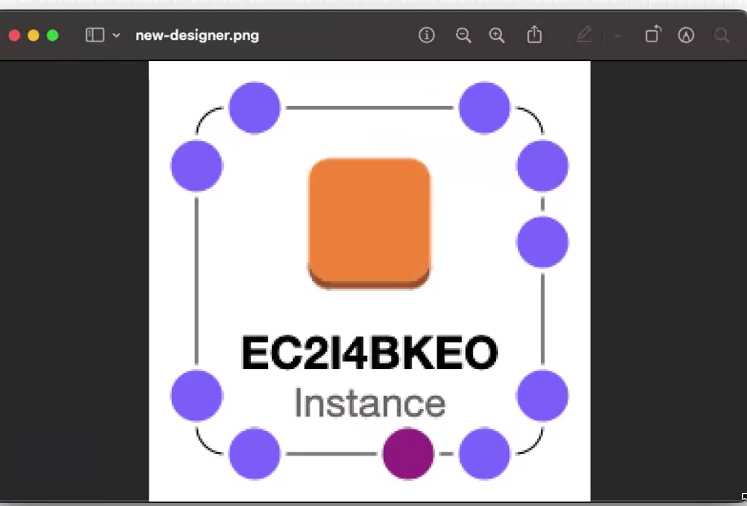

Step 6: Change format to YAML

Image:

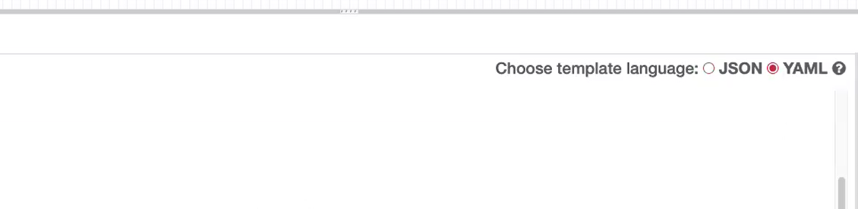

Step 7: Insert the template into the designer

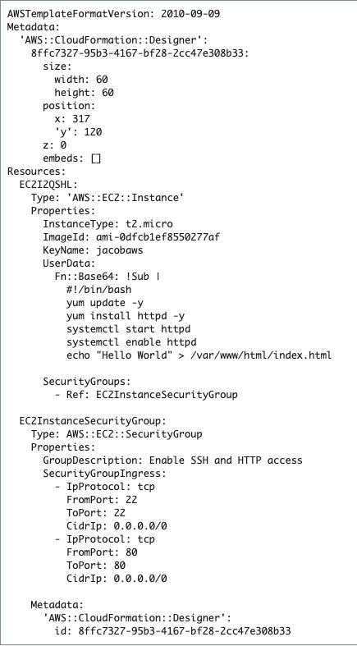

Step 8: Validate the Template inside the designer to ensure that there will be no errors.

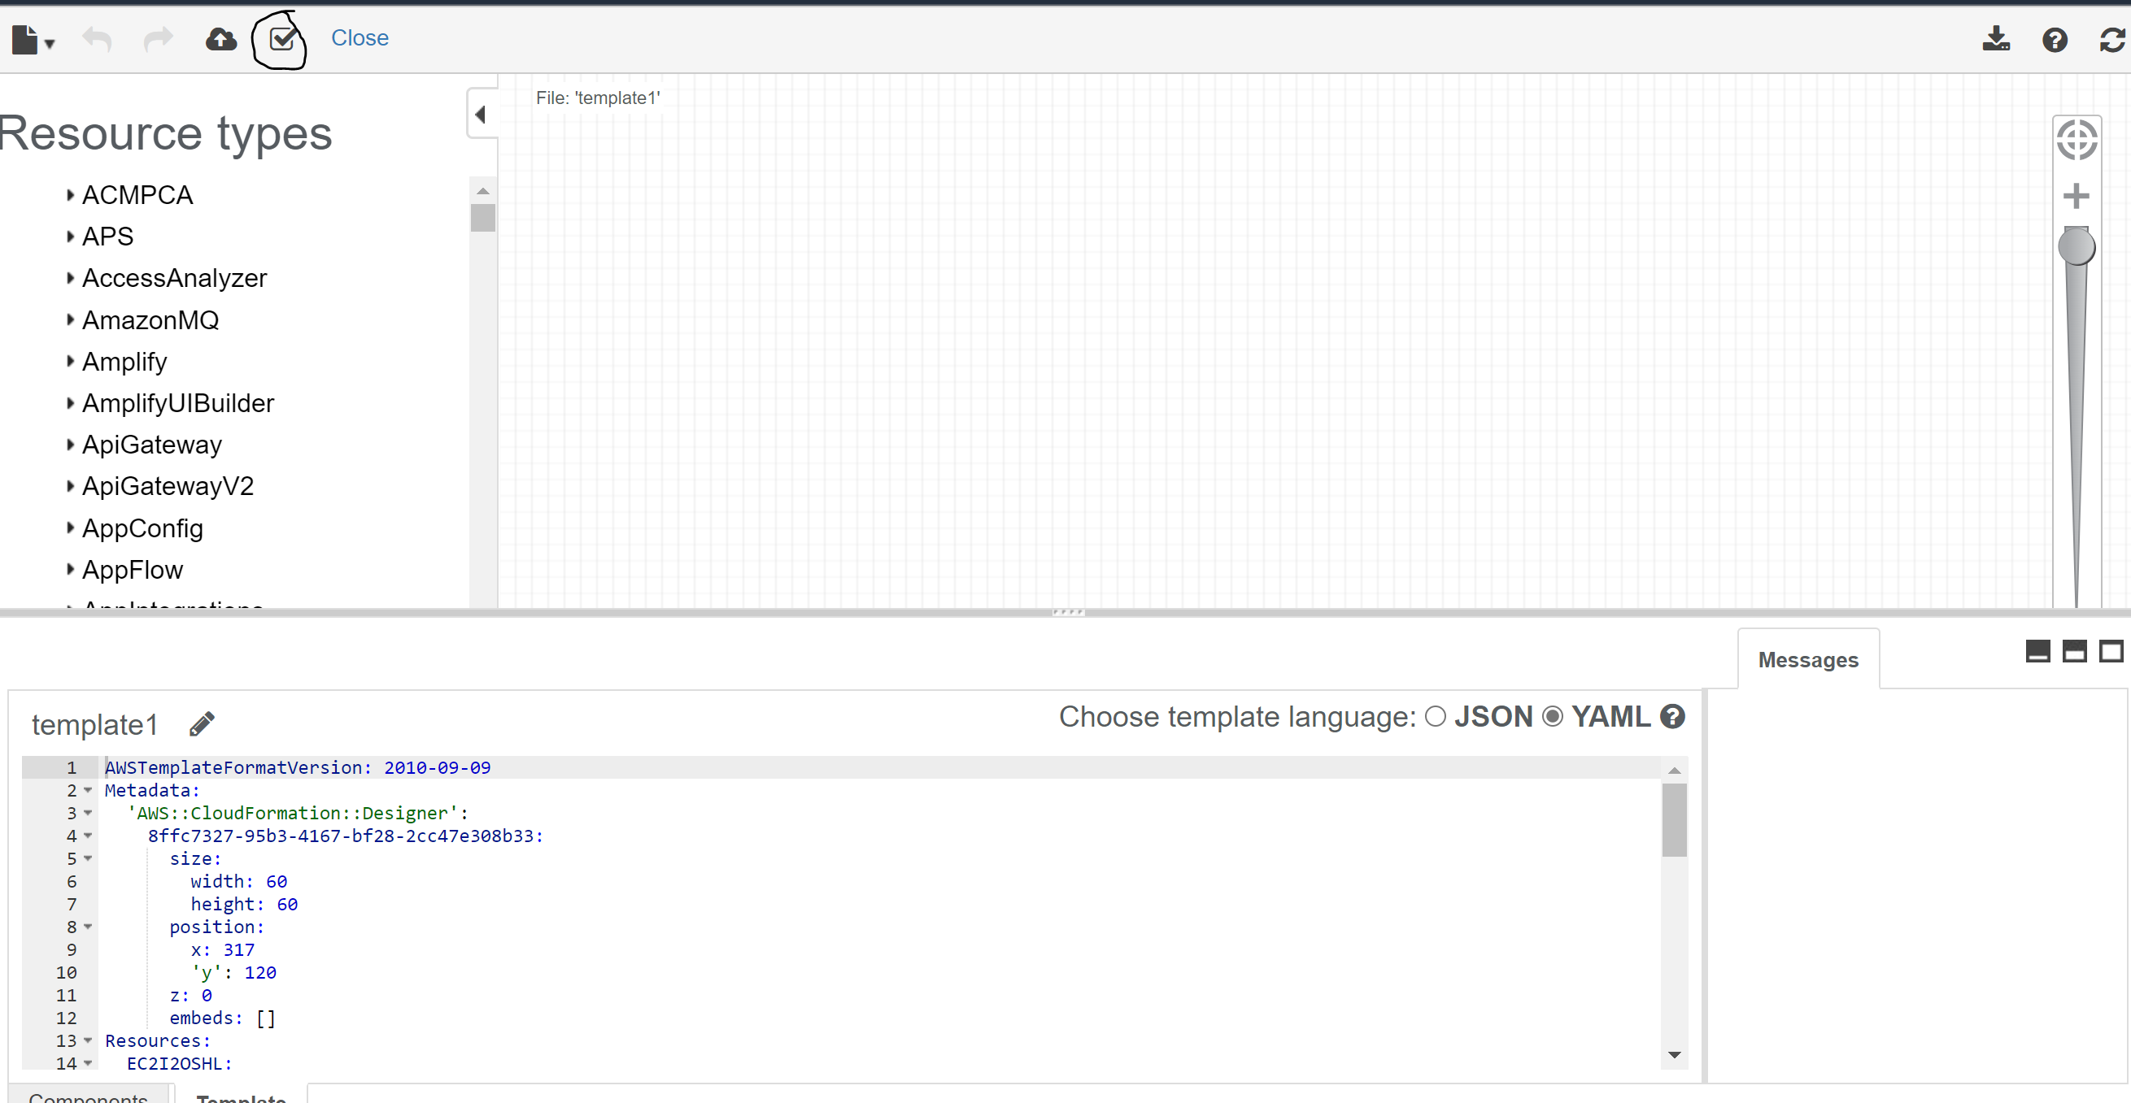

Step 9: Validate that Instance was created

Image:

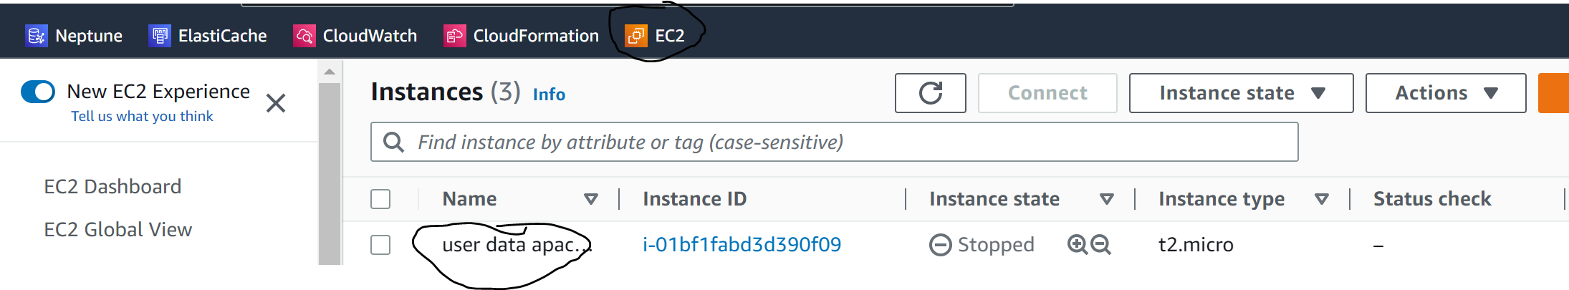

Step 10: Select Instance and select Public IPv4 DNS

Image:

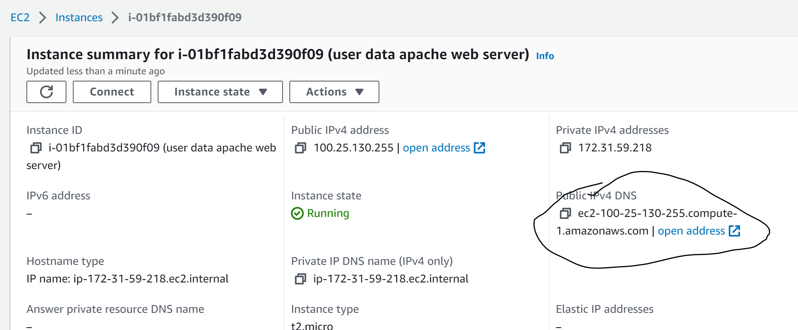

-

Step 11: View Contents of webpage

Image:



